**Graph Theory Intro Practice**

50.039 Theory and Practice of Deep Learning

# Exercises

Below are a few exercises for autonomous practice of the graph theory concepts we introduced earlier.

## Defining a graph

Let us consider the following molecule, below, the beloved ethanol.

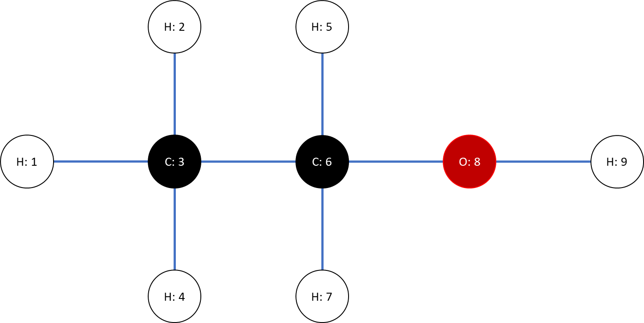

This molecule could be represented as a graph. But to do so, it requires to answer a few questions first, listed below.

1. We denote $N$, the number of vertices in this graph.  
   How many vertices does this graph contain?
2. Is this graph directed or undirected?
3. Assuming we refer to nodes as $x_{i}$, with $i∈\{1, 2, …, N\}$, what could the node features $h_{i}$ consist of? Discuss.
4. What is the adjacency matrix A of this graph?
5. What is the degree matrix D of this graph?
6. Consider the sentence below.

*“A Carbon atom can form four covalent bonds, an Oxygen atom can form two and an Hydrogen atom can form one.”*  
How does this concept of covalent bonds relate to graph theory?

## Laplacian matrix of a complete graph

Consider the definition below.

*“A complete graph is a graph in which each pair of graph nodes is connected by an edge.”*

Let us now consider a complete undirected graph with $N$ nodes, $N>3$.

1. What is the degree of each node in the graph?
2. What is the adjacency matrix $A$ for this complete graph looking like?
3. What is the Laplacian matrix $L$ for this complete graph looking like?
4. (Optional challenge) What are the eigenvalues of the Laplacian matrix for this graph?

## Degree of a graph

Let us consider a group of 8 friends, who decide to shake hands with each other.  
How many handshakes took place in the end?  
How does this question relate to graph theory?

## Diameter of a graph

Consider the definition below.

*“The diameter $D_{G}$ of a graph $G$*  the maximum hop-distance $d(x_{i} →x_{j})$ between any two pair of distinct vertices $x_{i}$ and $x_{j}$ in the graph $G$, or in other words

$$D_{G}=\max_{\begin{aligned}i, j \\ i≠j \end{aligned}}{(d(x_{i} →x_{j}))}$$

1. What is the diameter of the ethanol graph from Q1?
2. What is the diameter of a complete graph with $N$ nodes?

# Solutions

Below are the solutions for each exercise.

## Defining a graph

1. We have $N=9$ vertices in the graph, corresponding to the 9 atoms in the molecule.
2. This graph is undirected. The undirected property holds here: atom $x_{i}$ is connected to atom $x_{j}$ if and only if atom $x_{j}$ is connected to atom $x_{i}$.
3. The node features $h_{i}$ could simply consist of the atom name (C, O or H), for each atom $x_{i}$.
4. The adjacency matrix A is

$A=\left( \begin{matrix}\begin{matrix}0 & 0 & 1 \\ 0 & 0 & 1 \\ 1 & 1 & 0\end{matrix} & \begin{matrix}0 & 0 & 0 \\ 0 & 0 & 0 \\ 1 & 0 & 1\end{matrix} & \begin{matrix}0 & 0 & 0 \\ 0 & 0 & 0 \\ 0 & 0 & 0\end{matrix} \\ \begin{matrix}0 & 0 & 1 \\ 0 & 0 & 0 \\ 0 & 0 & 1\end{matrix} & \begin{matrix}0 & 0 & 0 \\ 0 & 0 & 1 \\ 0 & 1 & 0\end{matrix} & \begin{matrix}0 & 0 & 0 \\ 0 & 0 & 0 \\ 1 & 1 & 0\end{matrix} \\ \begin{matrix}0 & 0 & 0 \\ 0 & 0 & 0 \\ 0 & 0 & 0\end{matrix} & \begin{matrix}0 & 0 & 1 \\ 0 & 0 & 1 \\ 0 & 0 & 0\end{matrix} & \begin{matrix}0 & 0 & 0 \\ 0 & 0 & 1 \\ 0 & 1 & 0\end{matrix}\end{matrix}\right).$

1. The degree matrix D is
$$D=\left( \begin{matrix}\begin{matrix}1 & 0 & 0 \\ 0 & 1 & 0 \\ 0 & 0 & 4\end{matrix} & \begin{matrix}0 & 0 & 0 \\ 0 & 0 & 0 \\ 0 & 0 & 0\end{matrix} & \begin{matrix}0 & 0 & 0 \\ 0 & 0 & 0 \\ 0 & 0 & 0\end{matrix} \\ \begin{matrix}0 & 0 & 0 \\ 0 & 0 & 0 \\ 0 & 0 & 0\end{matrix} & \begin{matrix}1 & 0 & 0 \\ 0 & 1 & 0 \\ 0 & 0 & 4\end{matrix} & \begin{matrix}0 & 0 & 0 \\ 0 & 0 & 0 \\ 0 & 0 & 0\end{matrix} \\ \begin{matrix}0 & 0 & 0 \\ 0 & 0 & 0 \\ 0 & 0 & 0\end{matrix} & \begin{matrix}0 & 0 & 0 \\ 0 & 0 & 0 \\ 0 & 0 & 0\end{matrix} & \begin{matrix}1 & 0 & 0 \\ 0 & 2 & 0 \\ 0 & 0 & 1\end{matrix}\end{matrix}\right).$$

2. The number of covalent bonds for atom $h_{i}$ corresponds to the degree $d_{ii}$ of each node $x_{i}$ of the graph. This holds true for any index $i∈\left\{1, 2, …, N\right\}.$

## Degree of a graph

1. Each node has a degree value equal to $N-1.$
2. The adjacency matrix $A$ of a complete graph is a $N×N$ matrix with zeroes on the diagonal and ones everywhere else.
3. The Laplacian matrix of a complete graph a $N×N$ matrix with value $N-1$ on its diagonal elements and $-1$ everywhere else.
4. Only two eigenvalues for the Laplacian matrix of a complete graph with $N$ nodes. The first eigenvalue is $0$, which appears only once. We then have the eigenvalue $N$, which appears $N-1$ times.  
     
   The proof for this requires a bit of linear algebra, but is a good practice for the eigenvalues, eigenvectors and null space concepts:  
   <https://saadquader.wordpress.com/2013/04/25/eigenvalues-of-the-laplacian-matrix-of-the-complete-graph/>

## Degree of a graph

We could define a graph, where each of the 8 friends are nodes, and the edges represent the handshakes. This graph appears to be a complete graph with $N=8$ nodes, and each node would have a degree $d=7$.

The degree of the undirected graph would then be

$$D=\frac{Nd}{2}=\frac{8×7}{2}=28.$$

This is the total number of handshakes, which could have also been calculated as

$$\sum_{i=1}^{7}{i}=1+2+3+4+5+6+7=28.$$

Reason for second equation: First friend shakes hands with 7 friends, second friend has only 6 friends left to shake hands with, etc.

## Diameter of a graph

1. $R_{G} = 4$. The maximal hop-distance appears, for instance, between nodes 1 and 9.
2. All the nodes are immediately connected to each other in a complete graph. More specifically, we could prove quite easily that the hop-distance $d(x_{i} →x_{j})$ between any two pair of distinct vertices $x_{i}$ and $x_{j}$ of a complete graph is 1. Its radius $R_{G}$ is therefore 1 as well.